**Part 2: Group Presentation (70 Marks [10%]; Dec 4 In-Class)**

Your team will create a slideshow and give a presentation summarizing your project and your

code. The presentation should be about 5 minutes following with a 2-minute Q&A. All group

members need to participate in the presentation in order to count towards their grade. The slide

show should consist of the following sections:

• Identify the problem you wish to solve and the scope of your project

• Background of the problem

• Description of how your group solved the problem with GIS programming

• A flowchart illustrating your data processing and programming

• Analysis of your work and results

• Description of each team member’s contribution

**Part 3: Presentation Slides, ArcMap Tool with Python Code, and Data (Due Dec 4 In-Class)**

You have to submit your presentation slides (in the format of PowerPoint), ArcMap tool with Python

code, and the data to Quercus before the in-class presentation in order to get your marks for the group

Project.

## Story Map: <https://storymaps.arcgis.com/stories/ef0c1c29c1444b34ab4ade01f3666ce0>

## Process:

Model builder was used:

1. Parks file was projected to NAD 83 UTM Zone 17

2. **Feature to point tool** was used to convert the parks polygons to points

3. **Kernel density tool** was used to produce a raster layer showing the density of points

4. A **Buffer tool** was usedfor the parks file using the parameters:

* 300m distance
* Outside polygon
* Dissolve all

5. The area that is not within the buffer coverage of the park is erased using the **Erase tool** where:  
- Toronto boundary and the buffer layer is used as input

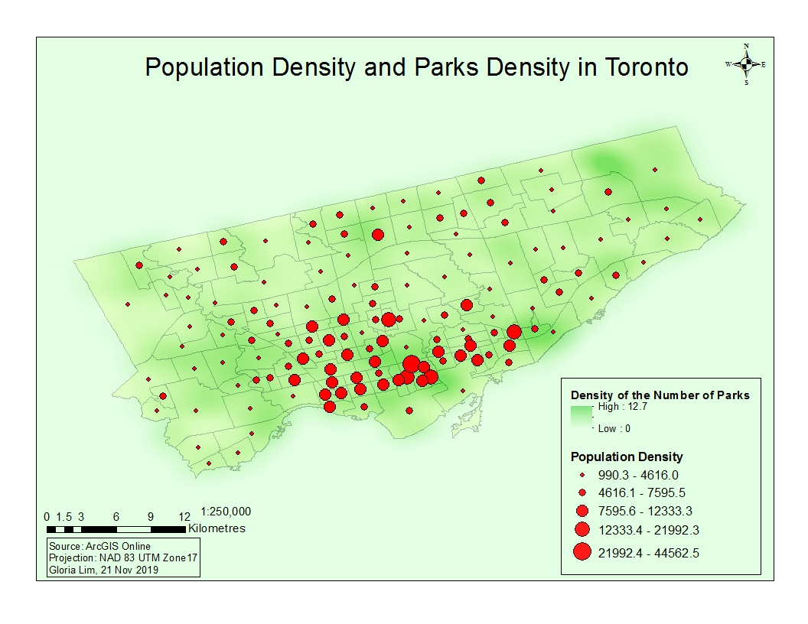

In the process of finding the locations of areas with low park density this map of the kernel density of the current parks in Toronto was created.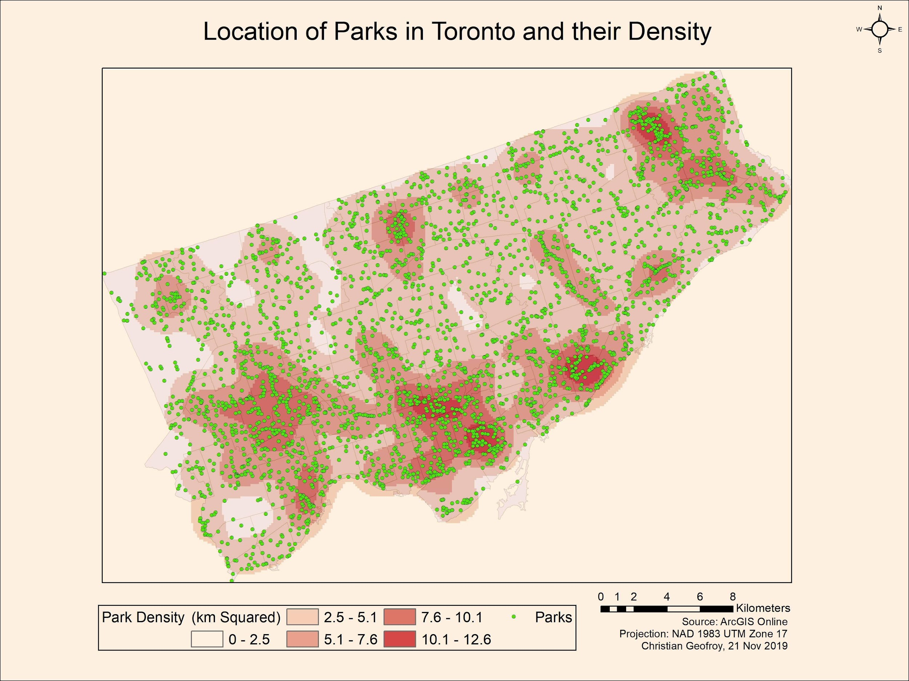

This map only takes into account the number of parks and not the size.

There are clusters of parks in the downtown area, Rexdale/Weston area, North York area, Scarborough Bluffs area and the Rouge National Urban Park area.

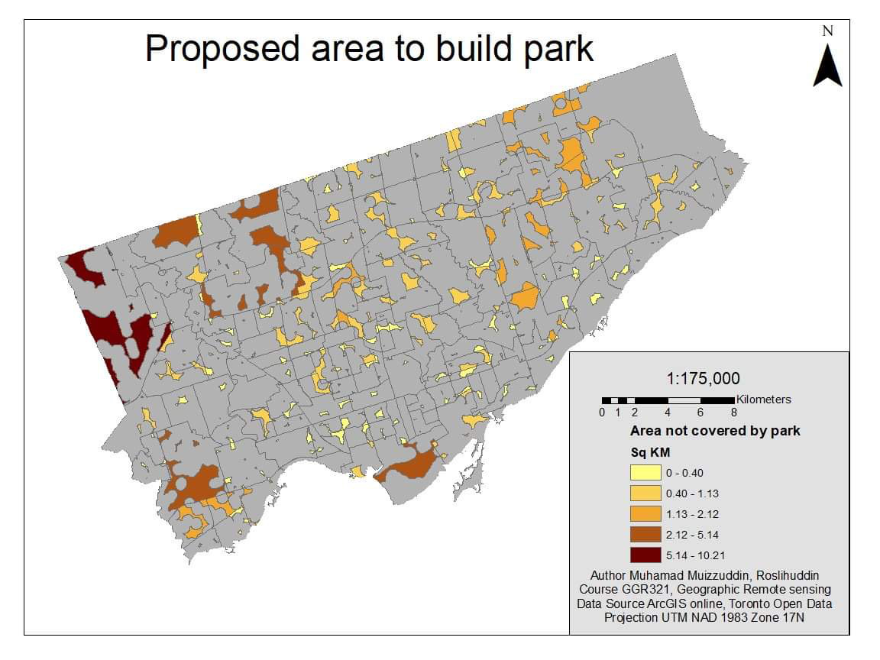

Intro:  
Living in cities, we tend to forget how dependent we are on nature. Cities are not self-sustaining.

Propose to create walkable neighbourhoods, network of greenspaces

Code script.py

#If you want this code to work on your computer make sure you change the environment and change file name, if necessary.

#import system modules

import arcpy

import arcpy as env

#set environment settings for input workspace.

env.workspace = "C:\\Users\\jsk\\Documents\\GGR321\\group project"

#sets path to shapefiles found on open source

sidewalk = "Sidewalk_Inventory_wgs84.shp"

park = "CITY_GREEN_SPACE_WGS84.shp"

city = "City Wards Data.shp"

#sets file name for future

parkToPoint = "parkPoint.shp"

parkToPointBuffer ="parkPointBuffer.shp"

#changes parks feature to points

FeatureToPoint(park, parkToPoint, "CENTROID")

#buffers park points to 300m

Buffer_analysis (parkToPoint, ParkToPointBuffer, 300 Meters)

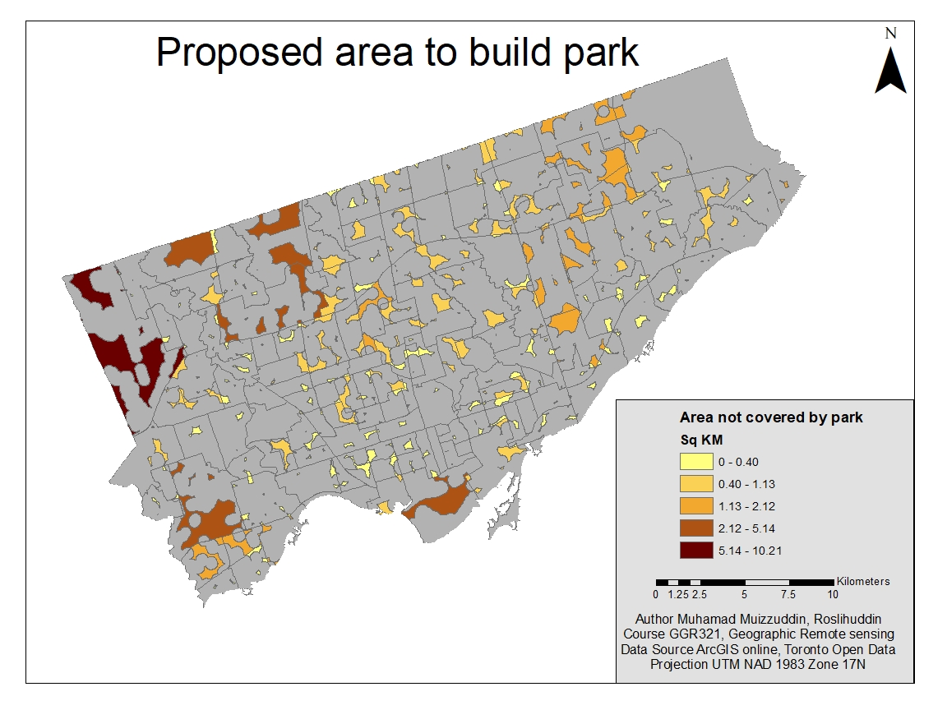

# Set the necessary product code

# import arcinfo

# Import arcpy module

import arcpy

# Local variables:

Toronto_whole_shp = "\\\\medusa\\StudentWork\\roslihud\\GGR321\\Urgent\\Group Project\\Toronto_whole.shp"

CITY_GREEN_SPACE_WGS84 = "CITY_GREEN_SPACE_WGS84"

Buffer_park_shp = "\\\\medusa\\StudentWork\\roslihud\\GGR321\\Urgent\\Group Project\\New Folder\\Buffer_park.shp"

Toronto_whole_Erase_shp = "\\\\medusa\\StudentWork\\roslihud\\GGR321\\Urgent\\Group Project\\New Folder\\Toronto_whole_Erase.shp"

Toronto_Neighbourhoods = "Toronto_Neighbourhoods"

Toronto_whole_Erase_Intersec_shp = "\\\\medusa\\StudentWork\\roslihud\\GGR321\\Urgent\\Group Project\\New Folder\\Toronto_whole_Erase_Intersec.shp"

Modified_Input_Features = Toronto_whole_Erase_Intersec_shp

# Process: Buffer

arcpy.Buffer_analysis(CITY_GREEN_SPACE_WGS84, Buffer_park_shp, "300 Meters", "FULL", "ROUND", "ALL", "", "PLANAR")

# Process: Erase

arcpy.Erase_analysis(Toronto_whole_shp, Buffer_park_shp, Toronto_whole_Erase_shp, "")

# Process: Intersect

arcpy.Intersect_analysis("'\\\\medusa\\StudentWork\\roslihud\\GGR321\\Urgent\\Group Project\\New Folder\\Toronto_whole_Erase.shp' #;Toronto_Neighbourhoods #", Toronto_whole_Erase_Intersec_shp, "ONLY_FID", "", "INPUT")

# Process: Add Geometry Attributes

arcpy.AddGeometryAttributes_management(Toronto_whole_Erase_Intersec_shp, "AREA_GEODESIC;CENTROID_INSIDE", "METERS", "SQUARE_KILOMETERS", "PROJCS['NAD_1983_UTM_Zone_17N',GEOGCS['GCS_North_American_1983',DATUM['D_North_American_1983',SPHEROID['GRS_1980',6378137.0,298.257222101]],PRIMEM['Greenwich',0.0],UNIT['Degree',0.0174532925199433]],PROJECTION['Transverse_Mercator'],PARAMETER['False_Easting',500000.0],PARAMETER['False_Northing',0.0],PARAMETER['Central_Meridian',-81.0],PARAMETER['Scale_Factor',0.9996],PARAMETER['Latitude_Of_Origin',0.0],UNIT['Meter',1.0]]")

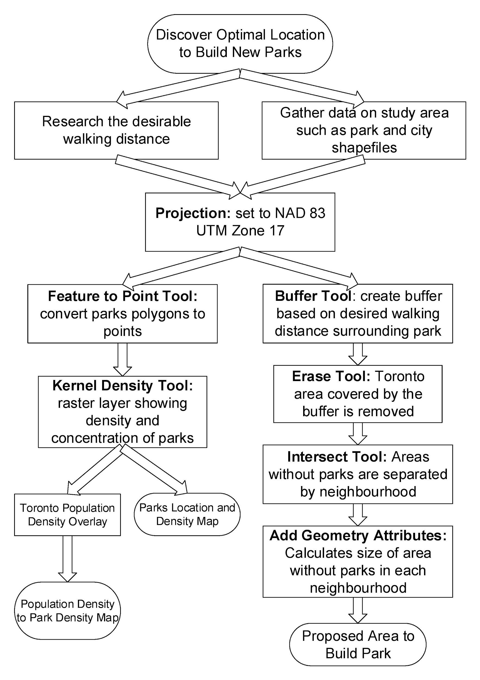

Member Contributions

**Christian Geofroy**: Created the Park Density map, helped with the presentation and brainstorming the idea

**Gloria Lim**: Suggested the use of ArcGIS Story Map, created introduction, created parks and population density map.

**Jong Su Kim:** Help develop python script

**Muhamad Muizzuddin Roslihuddin:**

**Ziran Jeffery Zhou:**Topic brainstorming, research, methods and flowchart.

Jong Soo’s code:

#import system modules

import arcpy

from arcpy import env

#set environment settings for input workspace.

env.workspace = "C:\\Users\\jsk\\Documents\\GGR321\\group project\\new"

# Local variables as parameters:

#city ward

city_boundary = arcpy.GetParameter(0)

#park shapefile

park = arcpy.GetParameter(1)

Toronto_Neighbourhoods = arcpy.GetParameter(2)

bufferZone= arcpy.GetParameterAsText(3)

#proceesses location

Buffer_park = "Buffer_parks.shp"

Erase_buffer = "Erase_buffer_park.shp"

Toronto_whole_Erase_Intersec_shp = arcpy.GetParameterAsText(4)

#sets projection to parks

sr = arcpy.SpatialReference("NAD 1983 UTM Zone 17N")

arcpy.DefineProjection_management(park, sr)

# Process: Buffer

arcpy.Buffer_analysis(park, Buffer_park, bufferZone, "FULL", "ROUND", "ALL", "", "PLANAR")

# Process: Erase

arcpy.Erase_analysis(city_boundary, Buffer_park, Erase_buffer)

# Process: Intersect

arcpy.Intersect_analysis([Erase_buffer, Toronto_Neighbourhoods], Toronto_whole_Erase_Intersec_shp, "ONLY_FID", "", "INPUT")

# Process: Add Geometry Attributes

arcpy.AddGeometryAttributes_management(Toronto_whole_Erase_Intersec_shp, "AREA_GEODESIC;CENTROID_INSIDE", "METERS", "SQUARE_KILOMETERS", "PROJCS['NAD_1983_UTM_Zone_17N',GEOGCS['GCS_North_American_1983',DATUM['D_North_American_1983',SPHEROID['GRS_1980',6378137.0,298.257222101]],PRIMEM['Greenwich',0.0],UNIT['Degree',0.0174532925199433]],PROJECTION['Transverse_Mercator'],PARAMETER['False_Easting',500000.0],PARAMETER['False_Northing',0.0],PARAMETER['Central_Meridian',-81.0],PARAMETER['Scale_Factor',0.9996],PARAMETER['Latitude_Of_Origin',0.0],UNIT['Meter',1.0]]")

#delete temp files

arcpy.Delete_management(Buffer_park)

arcpy.Delete_management(Erase_buffer)